Record programs

- Create a web page with all types of Cascading style sheets.
- Create a HTML5 form that interacts with the user. Collect first name, last name and date of birth and display that information back to the user.

- Write HTML5 code to provide intra and inter document linking.

- Develop and demonstrate a HTML5 document that illustrates the use of ordered list, unordered list, table, borders, padding, color, and the <div> & <span> tag.

- Develop a HTML5 Form, which accepts any Mathematical expression. Write JavaScript code to evaluate the expression and Displays the result.

<html>
<head>
<title>Mathematical Expression</title>
<script language = "javascript">
function math_exp()
{
var x = document.form1.exptext.value;
var result = eval(x);
document.form1.resulttext.value = result;
}
</script>
</head>
<body >
<form name = "form1">
<table>
<tr>
<td>Expression</td>
<td><input type = "text" name = "exptext" /></td>
</tr>
<tr>
<td>Result</td>
<td><input type = "text" name = "resulttext" /></td>
</tr>
<tr>
<td><input type = "button" value = "calculate" onclick = "math_exp()" /></td>
</tr>
</table>
</form>
</body>
</html>
- Create a HTML5 form that has number of Textboxes. When the form runs in the Browser fill the textboxes with data. Write JavaScript code that verifies that all textboxes has been filled. If a textboxes has been left empty, popup an alert indicating which textbox has been left empty.

<html>
<head>
<title>Mathematical Expression</title>
<script language = "javascript">
function FormCheck()
{
if(f1.uname.value==null||f1.uname.value=="")
{
alert("please fill name");
return;
}
if(f1.mail.value==null||f1.mail.value=="")
{
alert("please fill email");
return;
}
if(f1.phone.value==null||f1.phone.value=="")
{
alert("please fill phone number");
return;
}
alert("you have filled all text boxes,Thank You")

}
</script>
</head>
<body >
<form name = "f1">
<table>
<tr>
<td>Enter Name</td>
<td><input type = "text" name = "uname" /></td>
</tr>
<tr>
<td>Enter Email</td>
<td><input type ="email" name = "mail" /></td>
</tr>
<tr>
<td>Enter Phone Number</td>
<td><input type = "naumber" name= "phone" /></td>
</tr>
<tr>
<td><input type= "button" value ="checkform" onclick ="FormCheck()" /></td>
</tr>
</table>
</form>
</body>
</html>

- . Create an HTML5 file for registration with three text fields name, mobile number and address. Write JavaScript to validate name, mobile number and address. Mobile number should be of 10 digits. Show alert message when user enter invalid entity.

<html>
<body >
<form name="Assignment1" action="https://www.vvitguntur.com"
method="post" onsubmit="return checkForm(Assignment1.user,Assignment1.address,Assignment1.phone)">
<table border=0 align=center>
<tr><td colspan=2 bgcolor=red align=center><font color=white size=5><b><u>Login</td></tr>
<tr><td> </td></tr>
<tr><td align=center>UserName: </td><td><input type="text" name="user"></td></tr>
<tr><td align=center>Address</td><td><textarea rows="5" cols="15" name="address"></textarea></td></tr>
<tr><td>Phone Number</td><td><input type="number" name=phone max="9999999999" min="6000000000"></td></tr>
<tr><td><br></td></tr>
<tr><td align=center colspan=2><input type="Submit" value="Submit">
<input type="reset" value="Reset"></td></tr>
<tr><td> </td></tr>
<tr><td colspan=2> ** If not registered <a href="register.html">Register Now</a></td></tr>
</table>
</form>
<script language="javascript">
function checkForm(user,address,phone)
{
if(user.value=="")
{
alert("User Name is Empty");
return false;
}
if(address.value=="")
{
alert("address is Empty");
return false;
}

if(phone.value=="")

{
alert("Phone fields Should not be empty");
return false;
}

}
</script>
</body>
</html>
- Write JDBC program to create table EMP with following fields
- Empid number(4)
- Ename varchar(20)
- Salary number(6)
- Address varchar(50)
- Write JDBC program to insert a record into EMP table.
- Write JDBC program to disply EMP table
11.Write JDBC program to update EMP table to set name as JOHN where Empid=501.
12.Write a Servlet program for Extending GenericServlet
it.java:
import javax.servlet.*;
import java.io.*;
public class it extends GenericServlet
{
public void service(ServletRequest req,ServletResponse res)throws ServletException,IOException
{
PrintWriter pw=res.getWriter();
res.setContentType("text/html");
pw.println("HI ROCKERS WECLOME TO SERVLET WORLD");
pw.close();
}
}
web.xml
<web-app>
<servlet>
<servlet-name>IT</servlet-name>
<servlet-class>it</servlet-class>
</servlet>
<servlet-mapping>
<servlet-name>IT</servlet-name>
<url-pattern>/it</url-pattern>
</servlet-mapping>
</web-app>

OUTPUT:

12.Write a Servlet program for Extending HttpServlet to read parameters.
name.java
import java.io.*;
import javax.servlet.*;
import javax.servlet.http.*;
public class name extends HttpServlet
{
public void doGet(HttpServletRequest req,HttpServletResponse res)throws
ServletException,IOException
{
String n,p;
res.setContentType("text/html");
PrintWriter pw=res.getWriter();
n=req.getParameter("uname");
p=req.getParameter("pwd");
pw.println("ur name is:"+n);
pw.println("your password is:"+p);
pw.close();
}
}
web.xml
<web-app>
<servlet>
<servlet-name>IT</servlet-name>
<servlet-class>name</servlet-class>
</servlet>
<servlet-mapping>
<servlet-name>IT</servlet-name>
<url-pattern>/name</url-pattern>
</servlet-mapping>
</web-app>

Login.html
<html>
<head>
<title>Login</title>
</head>
<body>
<form method="get" name="f" action="/it/name">
NAME:<input type="text" name="uname">
PASSWORD:<input type="password" name="pwd">
<input type="SUBMIT" value="Submit Details">
</form>
</body>
</html>

OUTPUT:

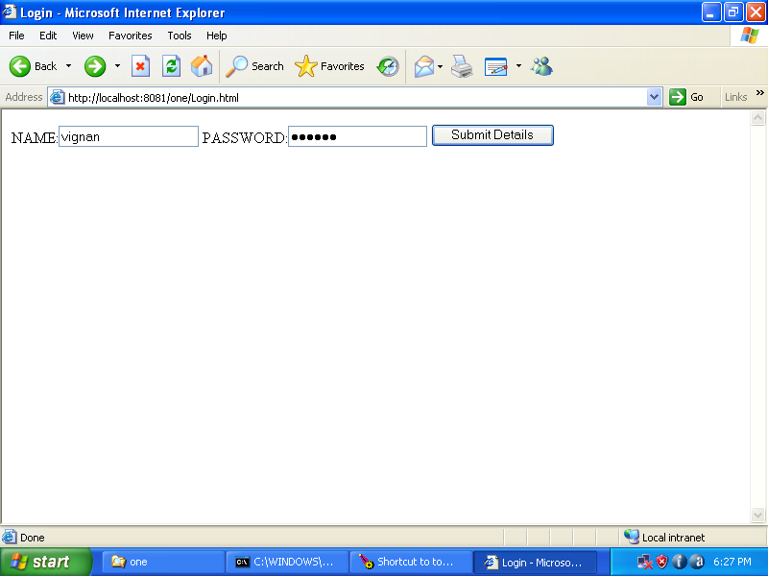

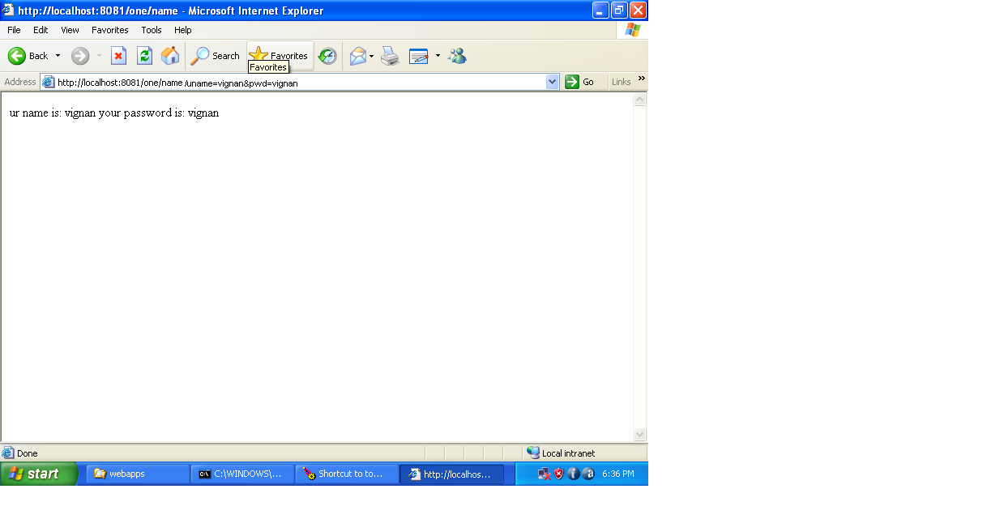

13.Write a servlet program to Read the contents from Cookies.

import javax.servlet.*;
import java.io.*;
import javax.servlet.http.*;
public class readcookies extends HttpServlet
{
public void doGet(HttpServletRequest req,HttpServletResponse res) throws ServletException,
IOException
{
Cookie cook[ ]=req.getCookies();
PrintWriter pw=res.getWriter();
for(int i=0;i<cook.length;i++)
{
pw.println("cookie variable:" +cook[i].getName());
pw.println("cookie value:" +cook[i].getValue());
}
pw.close();
}
}
read.html
<html>
<body>
<a href="http://localhost:8080/readcook/readcookies">
if u want to see the cookies then click here
</a>
</body>
</html>
web.xml
<web-app>
<servlet>
<servlet-name>hello</servlet-name>
<servlet-class>readcookies</servlet-class>
</servlet>
<servlet-mapping>
<servlet-name>hello</servlet-name>
<url-pattern>/readcookies</url-pattern>
</servlet-mapping>
</web-app>

OUTPUT:

14.Aim: Write a servlet program to Write the contents to Cookies.

import javax.servlet.*;
import java.io.*;
import javax.servlet.http.*;
public class writecookies extends HttpServlet
{
public void doGet(HttpServletRequest req,HttpServletResponse res)
throws ServletException, IOException
{
String name,password;
name=req.getParameter("uname");
password=req.getParameter("pwd");
Cookie cook1=new Cookie("your name is:",name);
Cookie cook2=new Cookie("your password is:",password);
cook1.setMaxAge(500);
cook2.setMaxAge(500);
res.addCookie(cook1);
res.addCookie(cook2);
PrintWriter pw=res.getWriter();
res.setContentType("text/html");
pw.println("cookies have been written to your system");
pw.close();
}
}
co.html
<html>
<head>
<title>cookies</title>
</head>
<body>
<h2>Login</h2>
<p>please enter your username and password</p>
<form method="get" action="/cook/writecookies">
<p>yourname<input type="text" name="uname" size="20"></p>
<p>password<input type="password" name="pwd" size="20"></p>
<p><input type="submit" value="submit" name="b1"></p>
</form>
</body>
</html>
web.xml
<web-app>
<servlet>
<servlet-name>hello</servlet-name>
<servlet-class>writecookies</servlet-class>
</servlet>
<servlet-mapping>
<servlet-name>hello</servlet-name>
<url-pattern>/writecookies</url-pattern>
</servlet-mapping>
</web-app>

15. Write Servlet to insert registration form data into database.
Registration.html
<html>
<body>
<form action="Reg" name="f">
<table>
<tr>
<td>Enter Name</td>
<td><input type="text" name="name"></td>
</tr>
<tr>
<td>Enter employee password</td>
<td><input type="password" name="pwd"></td>
</tr>
<tr>
<td>Enter Email</td>
<td><input type="email" name="email"></td>
</tr>
<tr>
<td>Enter employee Mobile</td>
<td><input type="number" name="phno"></td>
</tr>
<tr>
<td>Gender</td>
<td><input type="radio" name="gender" value="m">Male
<input type="radio" name="gender" value="f" checked>Female
</td>
</tr>
<tr>
<td>Qualification</td>
<td><select name="qualification">
<option>select</option>
<option value="B.Tech" selected>B.Tech</option>
<option value="M.Tech">M.Tech</option>
</td>
</tr>
<tr>
<td></td>
<td><input type="submit" value="register">
<input type="reset" value="cancel"></td>

</tr>
</table>
</body>
</html>

Reg.java
import javax.servlet.*;
import javax.servlet.http.*;
import java.sql.*;
import java.io.*;
public class Register extends HttpServlet
{
public void service(HttpServletRequest req,HttpServletResponse res)
throws IOException,ServletException
{
res.setContentType("text/html");
PrintWriter pw=res.getWriter();
String name=req.getParameter("name");
String pwd=req.getParameter("pwd");
String mail=req.getParameter("email");
long phno=Long.parseLong(req.getParameter("phno"));
String sex=req.getParameter("gender");
String quali=req.getParameter("qualification");
try
{

Class.forName("com.mysql.jdbc.Driver");
//create connection object
Connection con=DriverManager.getConnection( "jdbc:mysql:// localhost:3308/jeevan","root","root");
// create the prepared statement object
PreparedStatement ps=con.prepareStatement("insert into register values(?,?,?,?,?,?)");

ps.setString(1,name);
ps.setString(2,pwd);
ps.setString(3,mail);
ps.setLong(4,phno);
ps.setString(5,sex);
ps.setString(6,quali);
int i = ps.executeUpdate();
if(i>0)
pw.println(i+"You are successfully registered...");

}
catch (Exception ex)
{
ex.printStackTrace();
}
pw.close();
}
}

Web.xml
<web-app>
<servlet>
<servlet-name>Register</servlet-name>
<servlet-class>Register</servlet-class>
</servlet>
<servlet-mapping>
<servlet-name>Register</servlet-name>
<url-pattern>/Reg</url-pattern>
</servlet-mapping>
</web-app>
16. Write Servlet Program to Select data from Register table and display
17.Write servlet program to update password of a Particular user.
18. Create tables in the database which contain the details of items (books in our case Like Book name, Price, Quantity, Amount) of each category. Modify your catalogue page in such a way that you should connect to the database and extract data from the tables and display them in the catalogue page using JDBC
19. Write a JSP program to conduct online examination and to display student mark list available in a database.
Step1: create database student in mysql database
Step2: create table results(answer varchar(20));
Step3:insert into results(answer)values(‘Narendra Modi’);
Step 4: insert into results(answer)values(‘Gosling’);
Step5: insert into results(answer)values(‘Dennis Ritchie’);
Exam.html
<html>
<head>
<title>Online Exam Client</title>
<style type="text/css">
body{background-color:black;font-family:courier;color:red}
</style>
</head>
<body>
<h2 style="text-align:center">ONLINE EXAMINATION</h2>
<h3>Answer the following questions (5 marks for each correct answer)</h3>
<hr/>
<form name="exam" method="post" action="exam.jsp">
1.Who is the Prime Minister of India?<br/>
<input type="radio" name="ans1" value="Sachin">Sachin
<input type="radio" name="ans1" value="Rahul Gandhi">Rahul Gandhi
<input type="radio" name="ans1" value="Narendra Modi">Narendra Modi
<input type="radio" name="ans1" value="Manmohan Singh">Manmohan Singh
<br/><br/>
2.Who Developed Java?<br/>
<input type="radio" name="ans2" value="Dennis Ritchie">Dennis Ritchie
<input type="radio" name="ans2" value="Gosling">Gosling
<input type="radio" name="ans2" value="David Ritchie">David Ritchie
<input type="radio" name="ans2" value="John">John
<br/><br/>
3.C was developed by?<br/>
<input type="radio" name="ans3" value="Dennis Ritchie">Dennis Ritchie
<input type="radio" name="ans3" value="Stroustrup">Stroustrup
<input type="radio" name="ans3" value="David Ritchie">David Ritchie
<input type="radio" name="ans3" value="Charles Babbage">Charles Babbage
<br/><br/>
<input type="submit" value="Check Your Result"/>
</form>
</body>
</html>

exam.jsp:

<%@page contentType="text/html" language="java" import="java.sql.*"%>
<html>
<head>
<title>Online Exam Server</title>
<style type="text/css">
body{background-color:black;font-family:courier;color:blue}
</style>
</head>
<body>
<h2 style="text-align:center">ONLINE EXAMINATION</h2>
<p>
<a href="ExamClient.html">Back To Main Page</a>
</p>
<hr/>
<%
String str1=request.getParameter("ans1");
String str2=request.getParameter("ans2");
String str3=request.getParameter("ans3");
int mark=0;
Class.forName("com.mysql.jdbc.Driver");
Connection con=DriverManager.getConnection("jdbc:mysql://localhost:3306/student");
Statement stmt=con.createStatement();
ResultSet rs=stmt.executeQuery("SELECT * FROM results ");
int i=1;
while(rs.next())
{
if(i==1)
{
String dbans1=rs.getString(1);
if(str1.equals(dbans1))
{
mark=mark+5;
}
}
if(i==2)
{
String dbans2=rs.getString(1);
if(str2.equals(dbans2))
{
mark=mark+5;
}
}
if(i==3)
{
String dbans3=rs.getString(1);
if(str3.equals(dbans3))
{
mark=mark+5;
}
}
i++;
}
if(mark>=10)
{
out.println("<h4>Your Mark Is : "+mark+"</h4>");
out.println("<h3>Congratulations....! You Are Eligible For The Next Round...</h3>");
}
else
{
out.println("<h4>Your Mark is : "+mark+"</h4>");
out.println("<h3>Sorry....!! You Are Not Eligible For The Next Round...</h3>");
}
%>
</form>
</body>
</html>

